Paintings from Latvia

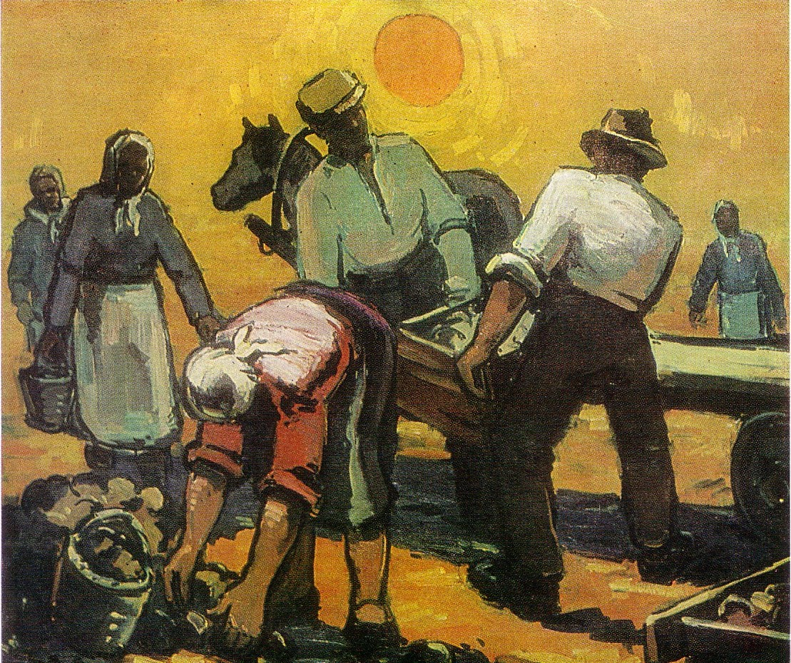

„Harvesting” 1960 by ĀDOLFS MELNĀRS

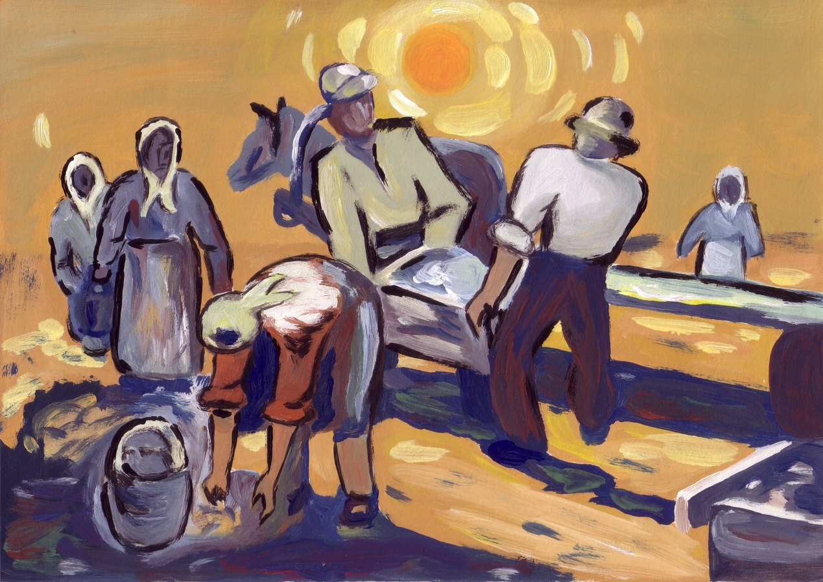

„Harvesting” 2012 by ANDA UZARE (19)

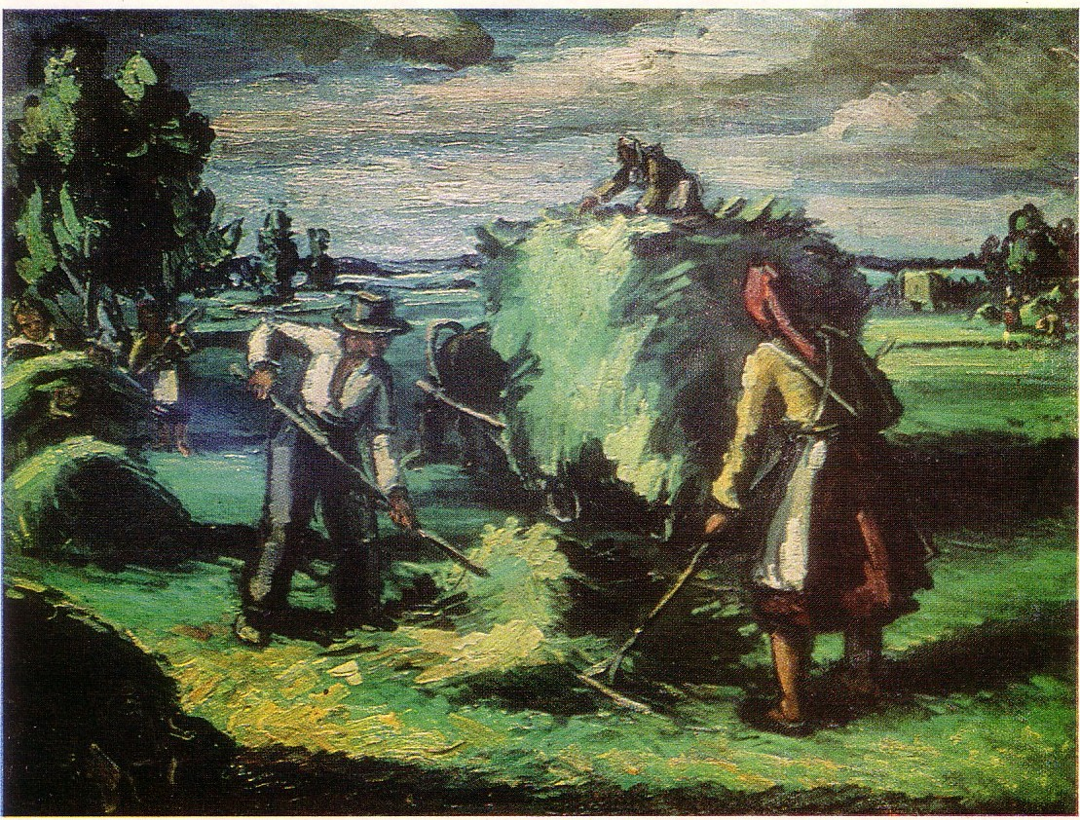

„Raking Hay” 1947 by ĀDOLFS MELNĀRS

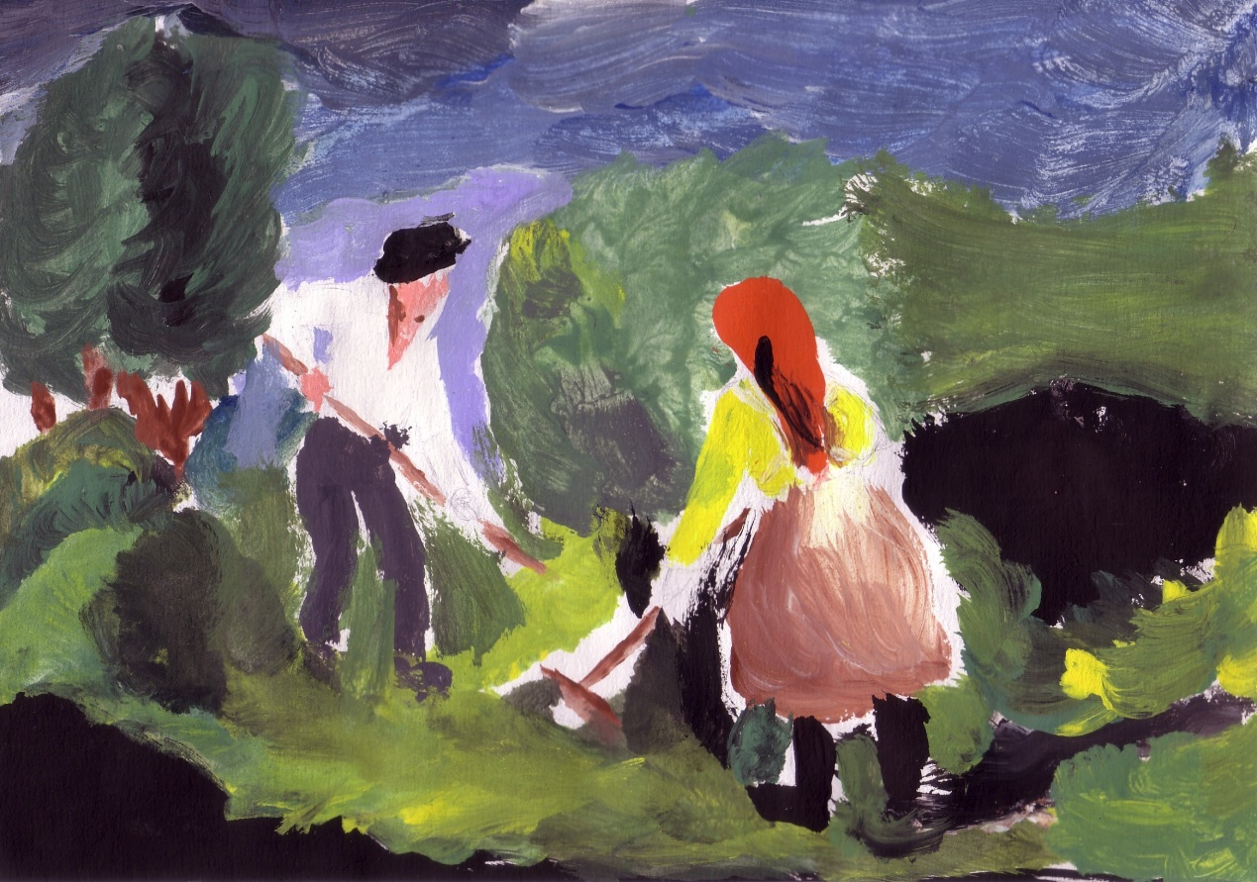

„Raking Hay” 2012 by ANNA ELĪZA ŠĒNA (13)

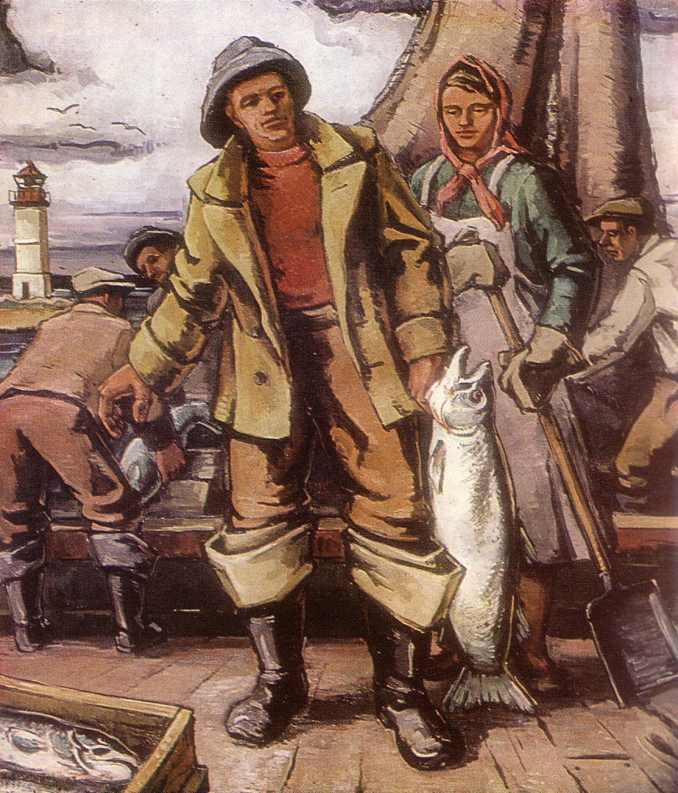

„Fisherman with Salomon” 1963 by ĀDOLFS MELNĀRS

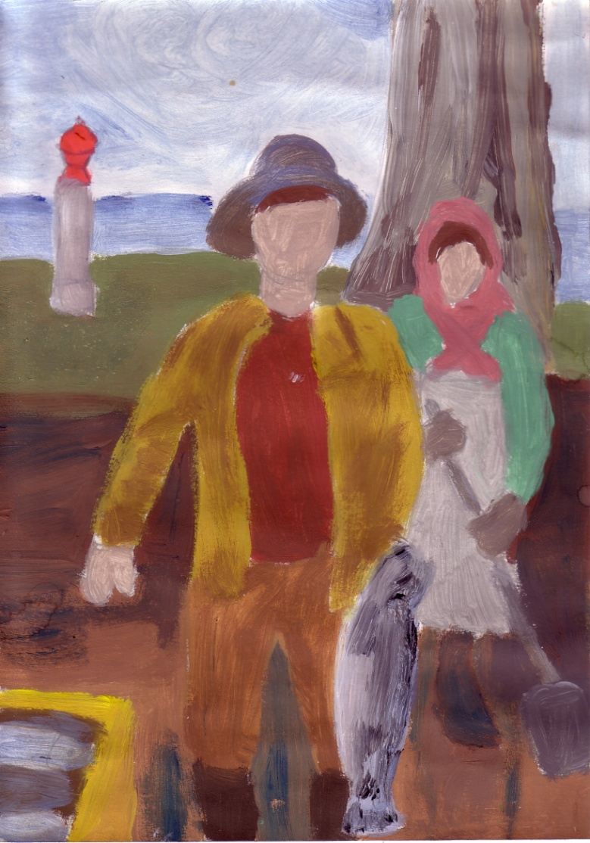

„Fisherman with Salomon” 2012 by AGNESE ĢĒĢERE (14)

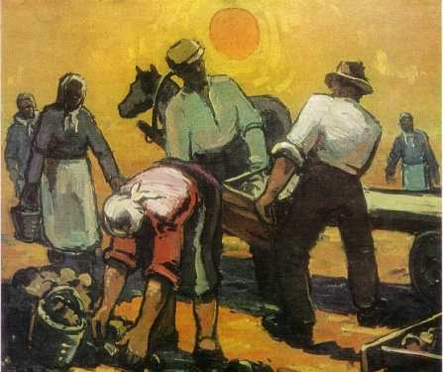

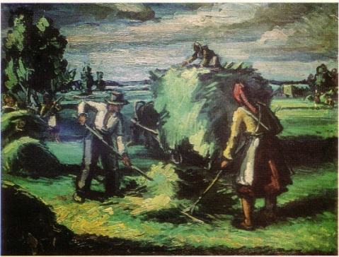

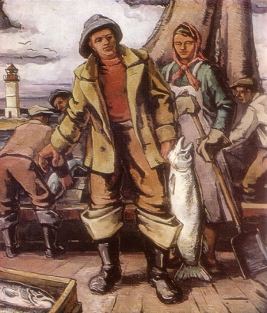

By Anda Uzare and Agnese Kurčānova Kraģe

Arnold’s Eureka

In the 19th a man called Arnold, a tall, well built man with blue eyes, and blonde hair was working on the hay field. He was raking when suddenly he realised that this work is totally boring. He decided to build a nice wooden boat.
Arnold organised a hardworking group of workers, who helped him to build his first boat. They were working day and night, but there was a small problem, what they did during the day, in the night everything got ruined and he had to start everything from the beginning. He did not know what to do, till one night when he saw a dream where a cod told him, that he must work only six hours a day and he has to give salted makrels for dinner to his workers and then the boat will be quickly ready. He did like the fish had told to do. Salted makrel is still one of the traditional Latvian foods, which is served with unpeeled potatoes and clotted cheese.
When the boat was ready they pulled the boat in river called Saka. The boat looked nice and it did not sink either. Later on he started to catch fish with the net. This net was made by his wife called Māra, a beautiful Latvian girl with long plaits and skin almost like a milk.
Actually she was very bad knitter that’s why his husband realised that he could take her work and use it as a net. He took some of his workers and they started to catch fishes.
One night he was walking along the sea, the moon was shining brightly and stars were blinking in the sky. Arnold sat on a wooden log and started to think how to cook fish because he was sick and tired of fried fish and fish soup. Next to him a couple was sitting around fire. Smoke was coming right to him. He quickly stood up and run back to home. All night he was building but he did not know what when he finished it he understood that he has made a thing where to smoke fishes. He set his own business. He started to sell fishes to neighbours and other village citizens.
Arnold felt for need to make not only boats but ships.
In the end Arnold became rich and famous for smoking fish and building boats.

